Reflections

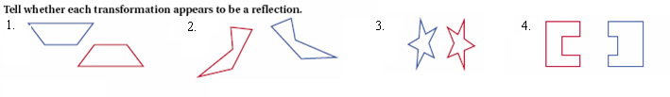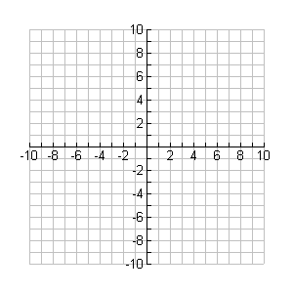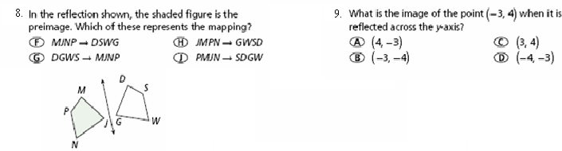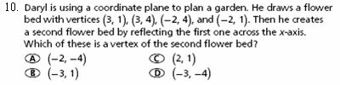

Translations

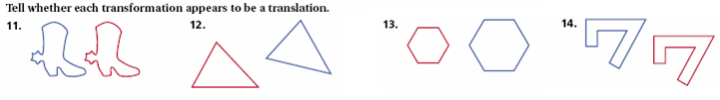

D’( , )

E’( , )

F’( , )

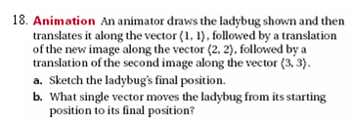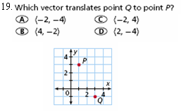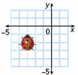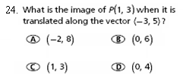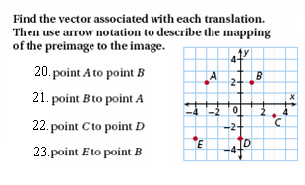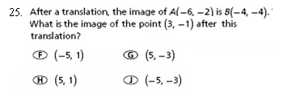

Rotations

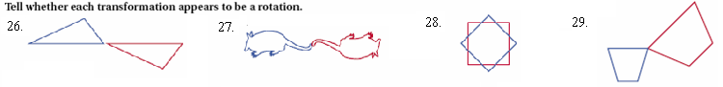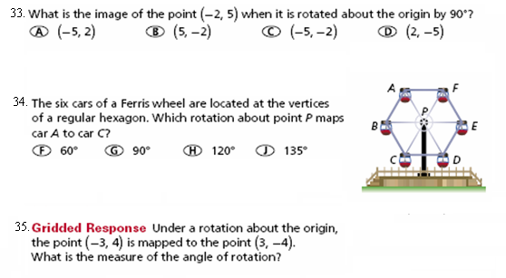

Mixed Practice

Tell whether each is a reflection, translation, rotation or none.

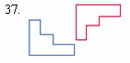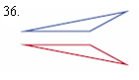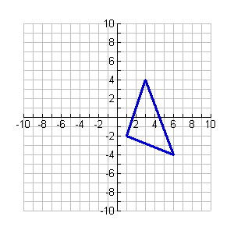

42. Triangle CAT is shown on the coordinate

plane. Which transformation would have one

vertex located at (1, 2)?

**A** Reflect across the y-axis.

**B** Translate down 3 units and left 1 unit.

**C** Reflect across the x-axis.

**D** Rotate 90° around the origin.



43. Triangle ABC is shown to the right. If the

Triangle is translated so that point A(1, -2) is mapped

To point A’(5, 1), which ordered pair best represents

**B**

Either point B’ or C’?

**A**

**A**  (0, 9)



**B**  (7, 7)

**C**



**C**  (6, 8)



**D**  (-1, 10)

